|  |
| --- |
| **Ideation Phase** |
| **Brainstorm & Idea Prioritization Template** |

|  |  |
| --- | --- |
| Date | 5 October 2022 |
| Team Id | PNT2022TMID39129 |
| Project Name | A Novel Method For Handwritten Digit Recognition System |
| Maximum Marks | 4 Marks |

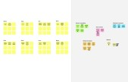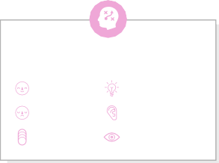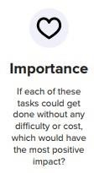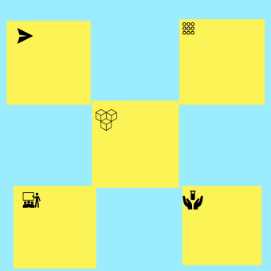

**Brainstorm**

**& idea prioritization**

Use this template in your own brainstorming sessions so your team can unleash their imagination and start shaping concepts even if you're not sitting in the same room.

**10 minutes** to prepare

**1 hour** to collaborate

**2-8 people** recommended

Before you collaborate

A little bit of preparation goes a long way with this session. Here’s what you need to do to get going.

**10 minutes**

1. **Team gathering**

Define who should participate in the session and send an

invite. Share relevant information or pre-work ahead.

1. **Set the goal**

Think about the problem you'll be focusing on solving in

the brainstorming session.

1. **Learn how to use the facilitation tools**

Use the Facilitation Superpowers to run a happy and

productive session.

[**Open article**](https://support.mural.co/en/articles/2113740-facilitation-superpowers)

**1**

Define your problem statement

To develope a Novel Method For Handwritten Digit Recognition System?

**5 minutes**

**PROBLEM**

**How might we develope a Novel Method For Handwritten Digit Recognition System?**

Key rules of brainstorming

To run an smooth and productive session

**2**

Brainstorm

Write down any ideas that come to mind that address your problem statement.

**10 minutes**

**M. Boomiga V. Kamaleshwari**

**Color identification**

**Pixel Size**

**Recognize Text**

**Identification of language in the given text**

**Acquisition of input from the user**

**Pixel Detection**

**Time Interval**

**Create GUI**

**to predict the digit**

**Identification of Stroke classification**

**Training of models**

**Classification of digit**

**Text Classification**

**3**

Group ideas

Take turns sharing your ideas while clustering similar or related notes as you go. In the last 10 minutes, give each cluster a sentence-like label. If a cluster is bigger than six sticky notes, try and see if you and break it up into smaller sub-groups.

**20 minutes**

**IDENTIFICATION**

## 

**Recognize Text**

**Space detection**

**4**

Prioritize

Your team should all be on the same page about what's important moving forward. Place your ideas on this grid to determine which ideas are important and which are feasible.

**20 minutes**

## 

**Identification of language in the given text**

**Identification of Stroke classification**

##### Identation

**Number of lines to be counted**

After you collaborate

You can export the mural as an image or pdf to share with members of your company who might find it helpful.

Quick add-ons

1. **Share the mural**

**Share a view link** to the mural with stakeholders to keep them in the loop about the outcomes of the session.

1. **Export the mural**

Export a copy of the mural as a PNG or PDF to attach to emails, include in slides, or save in your drive.

Keep moving forward

**Strategy blueprint**

Define the components of a new idea or strategy.

[**Open the template**](https://app.mural.co/template/e95f612a-f72a-4772-bc48-545aaa04e0c9/984865a6-0a96-4472-a48d-47639307b3ca)

**Customer experience journey map**

Stay in topic. Defer judgment.

**Symbol Classification**

**Time Interval**

Encourage wild ideas. Listen to others.

**Predict/ sense the image**

**Grabbing character to a grid**

**Text Classification**

Understand customer needs, motivations, and obstacles for an experience.

**[Open the template](https://app.mural.co/template/b7114010-3a67-4d63-a51d-6f2cedc9633f/c1b465ab-57af-4624-8faf-ebb312edc0eb)**

**Pixel Detection**

Go for volume. If possible, be visual.

**E. Saranya M. Reshma**

**MODULES**

**Color**

**identification**

**Predict/sense the image**

**Grabbing character to a grid**

**Capital letters**

**identification**

###### Acquisition Create GUI

**Classification of digit**

**Acquisition**

**Capital letters identification**

**Strengths, weaknesses, opportunities & threats**

Identify strengths, weaknesses, opportunities, and threats (SWOT) to develop a plan.

**Create GUI to predict the digit**

**[Open the template](https://app.mural.co/template/6a062671-89ee-4b76-9409-2603d8b098be/ca270343-1d54-4952-9d8c-fbc303ffd0f2)**

**Number of lines to be counted**

### Space detection

##### Paragraph Spacing

**of input from the user**

**Learning Modules**

**Learning Modules**

**Re-**

**Sampling**

**Pixel**

**Detection**

#### Training of models

**to predict the digit**

**Re- Samp****ling**

**Learning Modul****es**

**Identation**

# Training of models

[**Share template feedback**](https://muralco.typeform.com/to/CiqaHVat?typeform-source=app.mural.co)

[**Share template feedback**](https://muralco.typeform.com/to/CiqaHVat?typeform-source=app.mural.co)

**Feasibility**

Regardless of their importance, which tasks are more feasible than others? (Cost, time, effort, complexity, etc.)

**Template**

Need some inspiration?

See a finished version of this template to kickstart your work.

[**Open example**](https://app.mural.co/template/e5a93b7b-49f2-48c9-afd7-a635d860eba6/93f1b98d-b2d2-4695-8e85-7e9c0d2fd9b9)